Family History\Genealogy

While visiting Pop Pop their laptop started showing some issues, they may be looking at replacing it soon. One of his main concerns was his family history/genealogy information, so we took some steps to collect that data and see what we could do with it. Pop Pop was utilizing a program called PAWWriter for Mac to keep the family history up to date. We decided to grab a backup of what he had and see if we could at least access the data he had put in there for safekeeping. After a little bit of research we were able to grab the information and save it so that it can at least be restored somewhere if needed. Below is one method I found to restore it if anyone wants to look at it.

For the time being I am keeping the information in there static (it doesn’t appear to have Warwick or Cal in there yet) until I can figure out how best to make it shareable. Ideally I’d like to put this somewhere centralized where anyone in the family can look at it. At the moment I have a cloud backup of it as well as a local copy.

The data was stored in a .GED (GEDCOM) file that looks to be a fairly universal file format for Genealogical Data Communication, it’s likely we could import this information into almost any genealogy software (Ancestry, etc.). The original file from Pop Pop’s machine is here:



This can be opened in a text editor (double click->Open and use a text editor like Notepad or Notepad++ or Wordpad… etc.) or imported into another application – we could probably scrape data from this file to utilize somehow, but there are apparently plenty of existing applications that use this file format. Not having a MAC and not sure if I want to pay for something like Ancestry yet we found a free application called Ancestris that worked very easily. I will look into other alternatives as I’d like to make this shareable via the web as we make changes/additions.

In the interim if you are interested you can download Ancestris here – doesn’t appear to be any ads, fees, or licensing restrictions.

<https://www.ancestris.org/index.html>

Once installed there’s a fairly simple import process for a GEDCOM file under the File->Import menu:

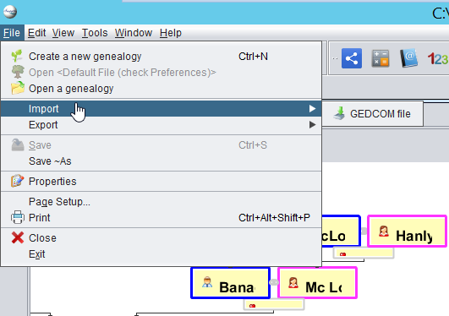

Once imported you can click between names to view information:

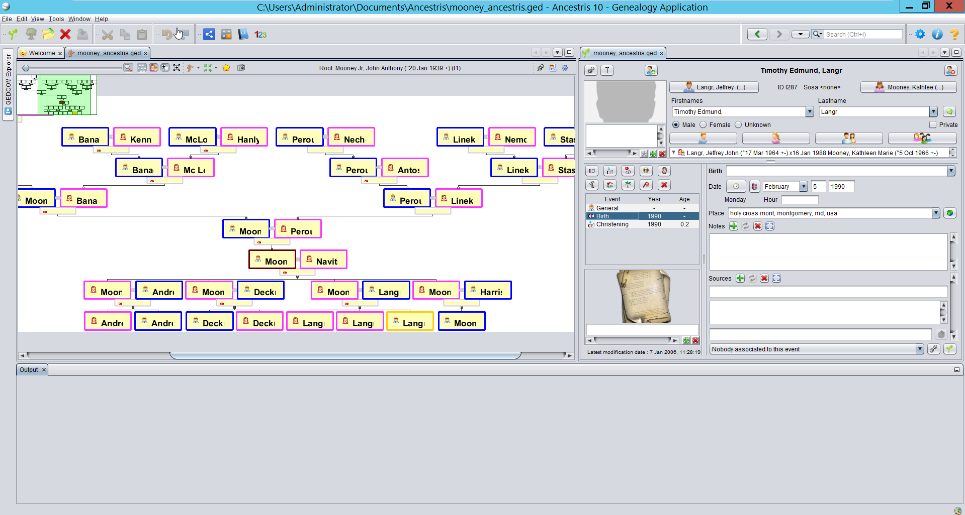

Until we figure out where to centralize this it will only save changes to your local machine. I’ll see if there’s any options I can find to make something like this that’s shareable via web so changes are seen by all, otherwise in the interim I’ll hang on to this and we can decided how to manage it.